1. **Till Now**:
   1. Why do we need **Unit Testing**?
   2. The basics of **Unit Testing**?
   3. The basic annotations.
   4. The basics assert methods such as assertEquals(<expected>, <actual>)
   5. Advanced Scenarios such as
      1. Testing Exceptions.
      2. Testing Performance.
      3. Parameterized Test.
      4. Test Suite.
2. **Agenda**:
   1. Mockito section is divided into 18 steps.
   2. In the first few steps, we will start with understanding the basics of **Mockito** and basics of **Mocking**.
   3. We will also see the other **alternatives to Mocking**.
   4. We will also go into **details** about **Mockito** where we will discuss the annotations and **Mockito runners**.
   5. We will also integrate **Mockito** with **PowerMock** to enable us to mock static methods and **constructors**.
3. **The repo for Mockito**:  
   <https://github.com/in28minutes/MockitoTutorialForBeginner>
4. <https://github.com/in28minutes/MockitoTutorialForBeginner>

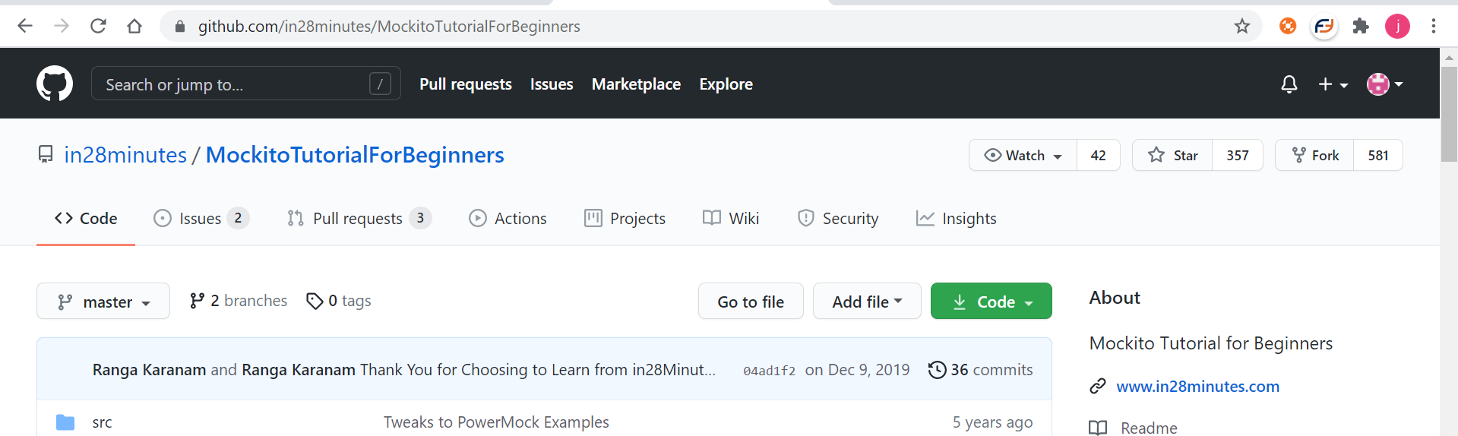

1. Clicking each step will open a page where you will see
   1. **Purpose**: What you will learn in this step?
   2. **Theory:**
   3. **Code:** The code snippet for the step.
2. 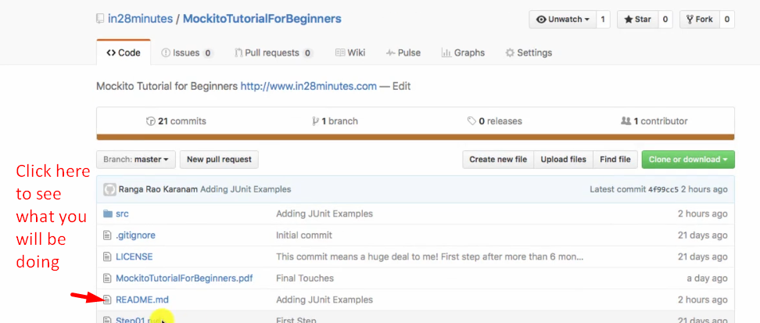
3. 